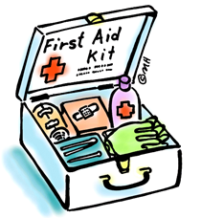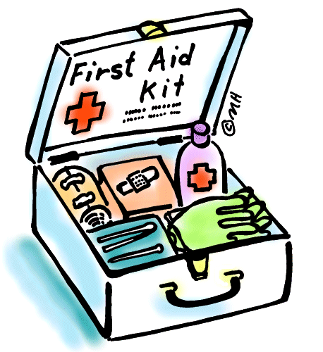**First Aiders Tendring District Council**

**Careline**

**Clare Lewis – 01255 686544**

**Eithne Houghton – 01255 686362 (Mobile Officer)**

**Pier Avenue**

**Jamie Timms – 01255 686784**

**Katie Jones – 01255 686235**

**Robert Goswell – 01255 686477**

**Daniel Kingham – 01255 686079**

**Laura Brittain – 01255 686292**

**Glenn Clark – 01255 686781**

**Ashley Wood – 01255 686594**

**Teagan Mead – 01255 686715**

**Northbourne Depot**

**Jason Barke (Not Office based) – N/A**

**Hannah Ibbotson – 01255 686734**

**Blake Lewis-Garrod (Not office based) – N/A**

**Jamie Davis (Not office based) – N/A**

**Keith Hurrell – 01255 686931**

**Chris Ball – 01255 686323**

**Brian Andrews – 01255 686640**

**Jay Honeywood – 01255 686959**

**Steve Mallery – 01255 686629**

**Town Hall**

**Tim Sutton – 01255 686012**

**Clare Lewis – 01255 686544**

**Wendy Bilsby – 01255 686653**

**Karen Breen – 01255 686349**

**Kai Aberdeen – 01255 686652**

**Billy Harvey – 01255 686668**

**Lauren Cuthbert – 01255 686309**

**Sharon Doolin – 01255 686946**

**Kelly Wright – 01255 686321**

**Gary Guiver – 01255 686173**

**Melissa Leek – 01255 686026**

**Nancy Sword – 01255 686139**

**Mustafa Neamatalla – 01255 686793**

**Paul Woods – 01255 686612**

**Weeley Crematorium**

**Paul Wilson – 01255 686673**

**Lucy Easton – 01255 686559**