Flood Plan

for

Name of Parish or Town Council

Contents

Chapter Title Page no.

- Introduction

- Background

- Warning Arrangements

- Flood Warning Codes

- Action to take on receipt of Flood Warnings

5.1 Beach Scenario

- Flood Mitigation

- Grab Bag

- What can you do? – Action Checklist

- Evacuation

- Insurance

- Pets

- When is it Safe to go back?

- How do I Recover?

- Awareness and Review

- Introduction

This section should explain the purpose of the plan.
How many people live in this area?
The community demographic.

- Background

This section should explain why the plan is necessary.

- Warning Arrangements

The Enviroment Agency issues flood warnings for coastal and river flooding.

The Met Office issue severe weather warnings for Heavy Rain. If your area is susceptible for surface water flooding or ground water flooding, detail here how you monitor the Met Office and what action you take when a severe weather warning for heavy rain is issued.

This section should state the arrangements the Parish or Town Council has in place for receiving Envionment Agency Flood Alerts and Warnings 24/7/365 for their area, if appropriate, and how this information is cascaded throughout the council and how you will liaise with Tnedinrg District Council.

Remember, on receipt of a FLOOD WARNING, SEVERE FLOOD WARNING and SEVERE WEATHER WARNINGS, Tendring District Council Emergency Planning Team will cascade these to those Parish and Town Councils who maybe affected.

4.0 Understand Flood Warning Codes

5.0 What Action will be taken on receipt of each code:
 Describe the action to be taken on receipt of this
Warning.
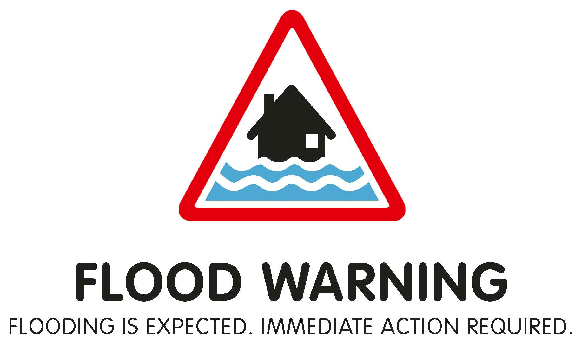 Describe the action to be taken on receipt of this
Warning.
 Describe the action to be taken on receipt of this
Warning.

Describe the action to be taken on receipt of this
Warning.

5.1 BREACH Scenario

In the event that a sea defence fails or is BREACHED, rapid inundation may follow. The Environment Agency cannot issue warnings for a BREACH. What are the plans for your area in this situation?

6.0 Flood Mitigation

This section should identify what flood mitigation measures have been purchased to protect the properties and infrasture in your area.( ie: airbrick covers, flood boards, sandbags)

You could reference Tendring District Council Sandbag Policy, Annex 1.

7.0 Prepare a Grab Bag

Describe the Grab Bag you have put together for your Council in the event you have to relocate..

8.0 What can you do? Checklist √

Does your council have any properties within a flood risk area. If so what can you do prior to the flood to mitigate it’s impact?

√ Can you move valuable or irreplaceable items to a first floor, or atleast
off the ground?
√ Roll up carpets / rugs
√ Consider moving your car to higher ground, if you are not going to use
it to self evacuate.
√ Lift and hang curtains over poles
√ Place important documentation in waterproof bag
√ Any large or loose items in your garden move or weigh them down.
√ Monitor Local TV and Radio Stations for further information
√ Know where and how to turn off your: Electricity, Gas, Water

9.0 Evacuation

Describe what arrangements you have in place should you be required to evacuate from your property. What is the safest evacuation route?

The decision to evacutate is not taken lightly and will be agreed by Essex Police and Tendring District Council. Follow the advice given by the responding organisations, it is for your safety.

How can you support Tendring District Council with an evacuation operation?

Can you pre-arrange to stay with relatives or friends who live outside of the flood zone in the event of an evacuation? This will relieve the burden on the Local Authority and assist those who have no other option.

10.0 Insurance

Does your Insurance provide you with adequate cover? Will they arrange alternative accommodation for you? Have you got copies of your insurance documentation and contact details?

11.0 Don’t forget your pets

Are you aware of any grazing or equatrian animals that would need to
be moved out of the flood warning area?

Do you know who to contact to get them moved?

Pets can be taken to Rest Centres, but are not allowed inside.

12.0 When is it safe to go back?

The responding organisations will be providing updates on the situation and notification when it is safe to return to the affected area. Follow their advice.

13.0 How do I recover?

√ Do not start the clean-up until the threat of further flooding has passed;
√ Don’t throw anything away until told to do so by your insurer;
√ Check with your insurance company if it is OK to start cleaning your
property, before you start;
√ Confirm what services your insurance company will pay for;
√ Use a permanent marker to mark on the wall the height of the flood water in
each affected room;
√ All surfaces that have been covered by flood water will be contaminated,
wear waterproof, gloves, boots and a face mask;
√ Household products are sufficient to clean and disinfect your property;
√ DO NOT attempt to reconnect your utilities yourself. Liaise with your utility
Provider;
√ DO NOT use vegetables and fruit from affected vegetable beds;
√ Use mains pressure garden hose for washing down, not high pressure
hose lines;
√ As soon as possible, ask your insurance company when a loss adjuster will
visit;
√ Ask your insurance company if they will pay for repairs that will make your
property more flood resilient for the future;
√ Keep records: date, time, name of person you spoke to and what was
agreed;
√ Keep receipts;
√ Take photos and video of your damaged property;
√ Make a list of your damaged property;

14.0 Awareness and Review

Explain how are you going make sure all the members of your council are aware of this plan?

Explain how often the plan will be reviewed / updated.

Annex 1: Tendring District Council Sandbag Policy 2015

Responsibility
The public has a general expectation that in a period of likely flooding Local Authorities will make sandbags available. This is not the case. Members of the public have a responsibility to protect their own properties. If their property is in a known flood plain or they consider they are at risk of flooding, then they should purchase sandbags in advance from local building suppliers.
Sandbags will only be issued by Tendring District Council in response to request from Emergency Services
Imminent flooding
If a property is at risk of being flooded, Tendring District Council will on request from Emergency Services send sandbags. Sandbags will not be provided for the protection of gardens, outbuildings or other structures.
Where Emergency Services are in attendance and make a request for sandbags, the Council will, if stocks permit, respond.
Shops, Businesses and Commercial Properties
The protection of shops, businesses and commercial properties is the responsibility of the owners or occupiers. They should undertake their own risk assessment and make provision for the supply and positioning of sandbags.
The Council will where possible respond to requests from the Emergency Services to protect strategic properties until the arrival and support of the owners or occupiers.
Delivery / Disposal of Sandbags
At times of high flood risk the Council will endeavour on request from the Emergency Services, deliver sandbags to occupied properties at imminent risk. However, this will not always be possible due to demand and / or weather conditions.
When sandbags are provided, they become the responsibility of the person receiving them. The Council will not accept liability for their placement; neither will the Council be responsible for collecting or disposing of issued sandbags

Charge for Sandbags
If there is a “Severe Flood Warning” issued or flooding is occurring there is no charge for sandbags from Tendring District Council. However, this deployment must be at the request of Emergency Services.

Note:
At times of actual or potential flooding owners of property look to ways that they might act to reduce the risks or impact on their property. The obvious quick fix is to try to prevent the ingress of water by providing a barrier of sandbags either around their property or at the portals to their buildings. Sandbags can be useful to deflect a flow of water but are not waterproof and therefore are generally ineffective in preventing standing water from entering a building. Water will also seep through the ground, airbricks and the brickwork itself. Caution must be exercised in using sandbags as differential water levels between the inside and outside of a building can induce structural failure.

