

[Insert your community name here]
Draft Emergency Plan template
Consultation document
Plan last updated on: xx/xx/xxxx

How to use this template: This template is designed for you to fill in the details of your community emergency preparations. There are notes in italics to help you fill the template. Detailed notes on how to create a plan can be found in the Community Emergency Plan Guidance document at
www.cabinetoffice.gov.uk/communityresilience

IF YOU ARE IN IMMEDIATE DANGER
CALL 999

Plan distribution list
Name | Role | Phone number/email address | Issued on
Example:  Ms Epo | Local Authority Emergency Planning Officer | 020 1234 5678 | DD/MM/YY
Mr Field | Local Environment Agency officer | 020 1234 5678
Miss Flood | Local Flood Warden | 020 1234 5678

Plan distribution list
Name | Date for next revision | Details of changes made | Changed by
Example:  DD/MM/YY | DD/MM/YY | Annex X added. | Community Emergency Coordinator
DD/MM/YY | DD/MM/YY | New Community Emergency Team members added. | Community Emergency Coordinator
DD/MM/YY | DD/MM/YY | Updated volunteer details. | Community Emergency Coordinator

Contents

Local Risk Assessment 4

Local Skills and Resources Assessment 4

Key locations 5

identified with local authority for use as places of safety 5

Emergency Contact List 5

Sample telephone tree 6

List of community organisations 7

Activation triggers 7

First steps in an emergency 8

Draft Community Emergency Group first meeting agenda 9

Actions agreed with local authority in the event of an evacuation 10

Alternative arrangements for staying in contact if usual communications have been disrupted 10

Local Risk Assessment

Risks | Impact on community | What can Community Emergency Group do to prepare?
Example:  River through village can flood | - Flooding of local streets  - Blocked access to town hall  - Damage to property | - Encourage residents to improve home flood defences  - Work with local emergency responders to see if can help with distribution of flood warnings and any evacuation and rest centre establishment required  - Find out what flood defences exist or are planned in the area

Local Skills and Resources Assessment

Skill/resource | Who? | Contact details | Location
Example:  Trained first aider | Sandy Fortman | 01700 5668xx | 17 Brookvale Street
4x4 owner/driver | Bob Southwold | 01700 5648xx | Garages to read of High Street
Chainsaw owner (tree surgeon) | Simon Chalmers | 01700 5605xx | Simon’s Landscaping – 4 Terrace Yard
Water/food supplies | Village Shop | 01700 5608xx | 2 High Street

Key locations
identified with local authority for use as places of safety

Building | Location | Potential usage in an emergency | Contact details
Example: Church Hall | 1 Church Square | Rest Centre/safe place | Colin Molesworth – Warden – 07749 8557xx
Watley Central; High School | Watley Street | Rest Centre/safe place | Jane Shulman – Caretaker – 07749 8655xx

Emergency Contact List

Photo | Example:  Name: Paul Ridgeway
Photo | Title: Community Emergency Coordinator
Photo | 24hr telephone contact: 07700 7785xx
Photo | Email: xx@xx.xx
Photo | Address: 2 Brook Road
Photo | Name:
Photo | Title:
Photo | 24hr telephone contact:
Photo | Email:
Photo | Address:

Sample telephone tree
The phone tree works as a pyramid, with the coordinator at the top making the first call to two or more people. In turn, they call an assigned set of people and so on, until the tree is complete.

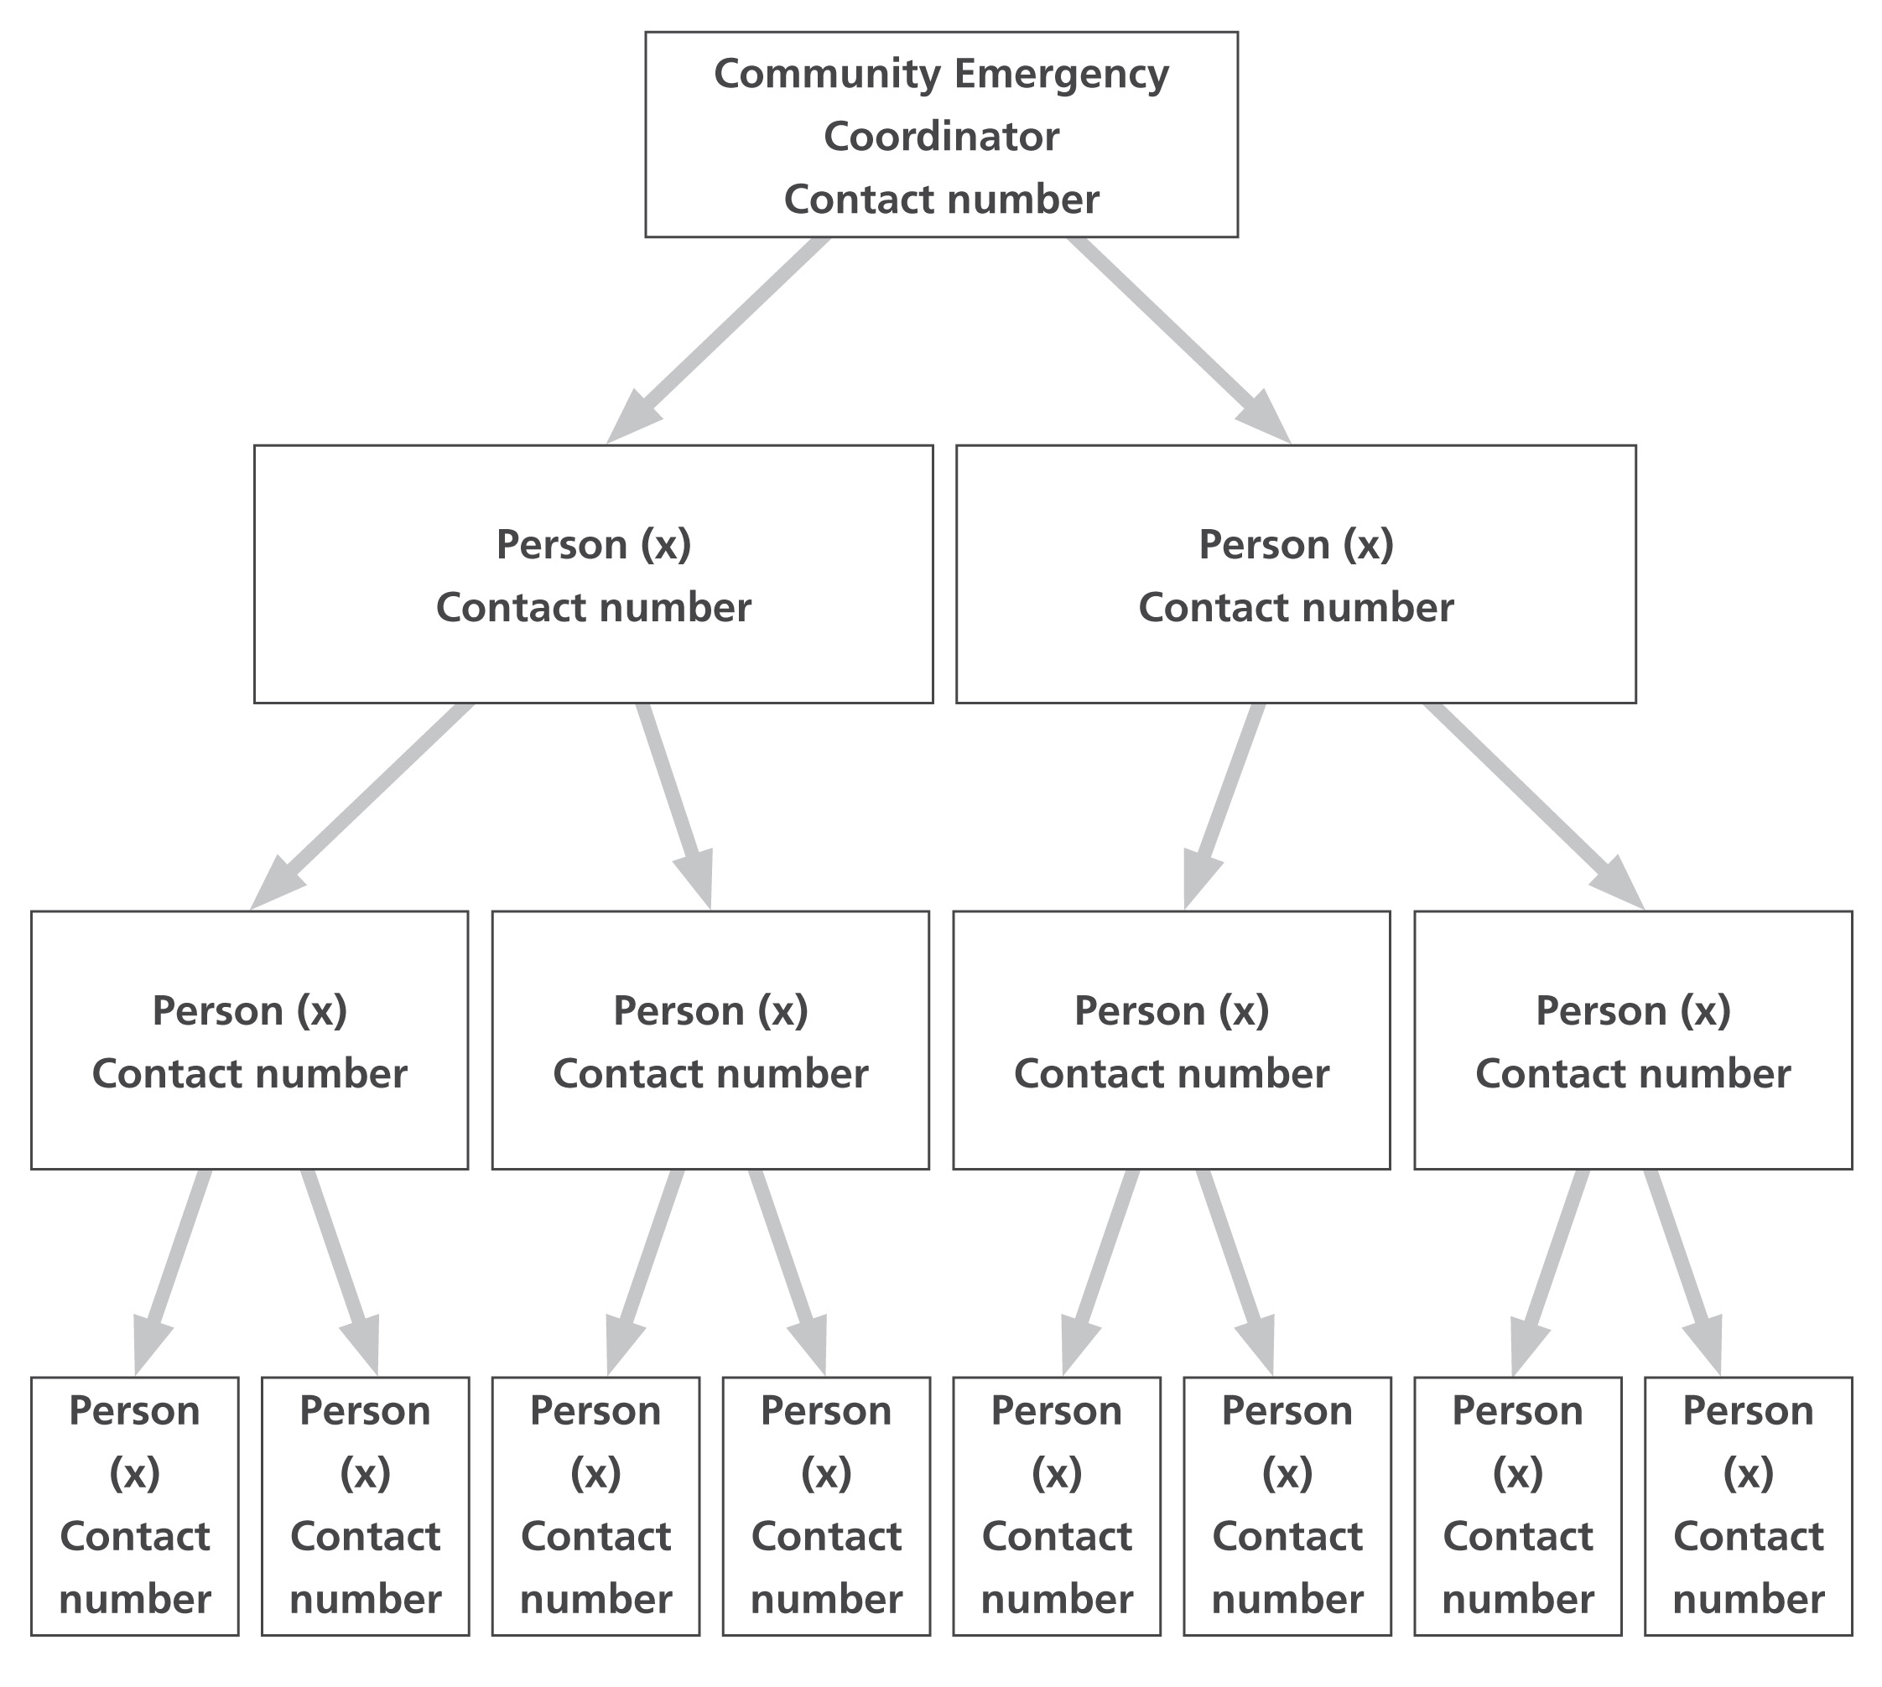
List of community organisations
that may be helpful in identifying vulnerable people or communities in an emergency
[Use this space to record details of organisations active in your local area that may be able to help you identify vulnerable people in an emergency.]

Activation triggers
[Use this space to record details of how your plan will be activated. You should include details of how the plan will be activated as a result of a call from the emergency services, and also how your community will decide to activate the plan yourselves, if the emergency services are unavailable]

First steps in an emergency
Follow the instructions below when the plan is activated.
 | Instructions | Tick
1 | Example: Call 999 (unless already alerted) | 
2 | Ensure you are in no immediate danger
3 | Contact the Community Emergency Group and meet to discuss the situation
4
5
6
7
8
9
10

Draft Community Emergency Group first meeting agenda

Example Community Emergency Group Emergency Meeting Agenda
Date:
Time:
Location:
Attendees:

1. What is the current situation?

You might want to consider the following:
Location of the emergency. Is it near:
- A school?
- A vulnerable area?
- A main access route?
- Type of emergency:
- Is there a threat to life?
- Has electricity, gas or water been affected?
Are there any vulnerable people involved?
- Elderly
- Families with children
- Non-English-speaking people.
- What resources do we need?
- Food?
- Off-road vehicles?
- Blankets?
- Shelter?

2. Establishing contact with the emergency services

3. How can we support the emergency services?

4. What actions can safely be taken?

5. Who is going to take the lead for the agreed actions?

6. Any other issues?

Actions agreed with local authority in the event of an evacuation
[Use this space to record details of the actions you can take to help your local authority if an evacuation is necessary in your community.]

Alternative arrangements for staying in contact if usual communications have been disrupted
[Use this space to record details of alternative communications within your local area should usual methods communications be disrupted. This could include the owner/locations of long distance walkie-talkies or details of your local Radio Amateurs’ Emergency Network (RAYNET) group]

